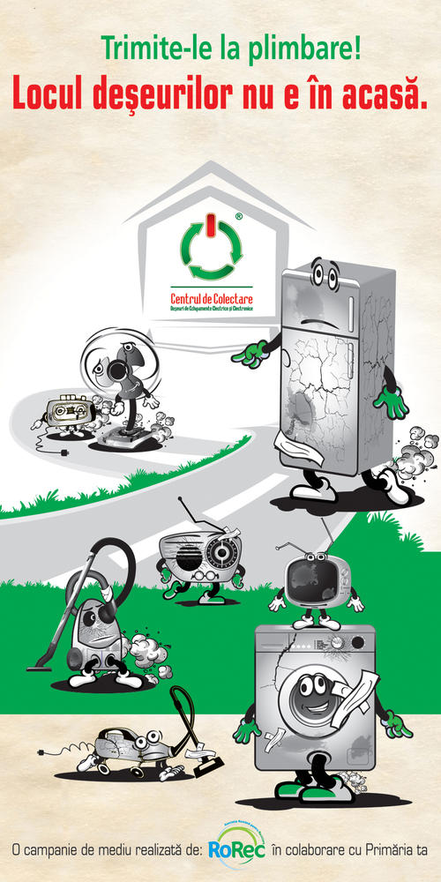
Hhhhhgggggggggggg
Vă așteptăm la sediul Liceului Teoretic Negru Vodă – str. Stadionului, nr. 50 cu DEEE – mașini de spălat, televizoare, calculatoare, frigidere, cuptoare, ceasuri, mixere, uscătoare de păr, mașini de tuns iarbă, imprimante, monitoare, aspiratoare, telefoane mobile, aparate radio, fiare de călcat, etc.
Campanie de colectare “Ecoprovocarea„ lansată de elevii Liceului Teoretic Negru Vodă, în perioada 11-13.04.2018 pentru deșeuri electrice, electronice și electrocasnice (DEEE)

fff

